Index Number: 22424262
End Of Semester Examinations
ASTA 607
?crabs

crabs is a dataset that describes the morphological measurements on 50 crabs each of two colour form and both sexes. The species that data was studies was Leptograpsus variegatus, which was collected in Australia. It also contains 200 rows and 8 columns.

crabs
str(crabs)
crabs
str(crabs)

The structure can be seen below as follows:
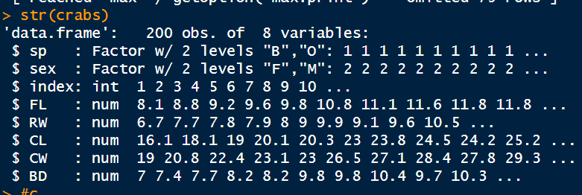

spFreqTable <- table(crabs$sp)
sexFreqTable <- table(crabs$sex)

spSexFreq <- table(crabs$sex, crabs$sp)
barplot(spSexFreq,
col = c("orange", "darkblue"),
legend.text = T,
)

- From the graph, you can see an equal number of observations for both species and sex with 50 observations each, showing that the data is balanced.

Q2.
par(mfrow = c(1,2))
spBp <- boxplot(BD ~ sp,
data = crabs,
col = c("orange", "darkblue")
)

sex_BP <- boxplot(BD ~ sex,
data = crabs,
col = c("palegreen", "yellow")
)

par(mfrow =c(1,1))

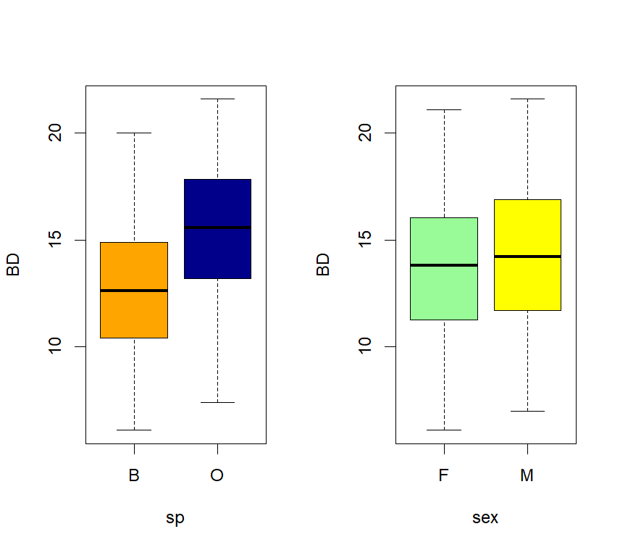
- From the box plot, it is clear that there are no outliers.
For species, O has higher its values ranging higher than B, with it median being slightly higher than 15, while B has its median value being around 13. Looking at where the median lies for both O and B, it is clear that there median lies close to the middle of box, showing very similar variability in both species.
Looking at the box plot for sex , it is clear that males have a slightly higher box than females. You can also see the median line for males are slightly higher that of females.
For the female box, you can see the lower box is slightly larger than the upper box, showing more variability in the 3rd quartile, while the male box has its upper box being slightly bigger, showing more variability.

Q3.
par(mfrow = c(1,2))
for (levels in levels(crabs$sp)) {
print(levels)
crabs_Sp <- crabs$CL[crabs$sp == levels]
hist(crabs_Sp,
col = c(5:7),
xlab = paste(levels),
main = paste("Histogram of CL of", levels)
)
},1))

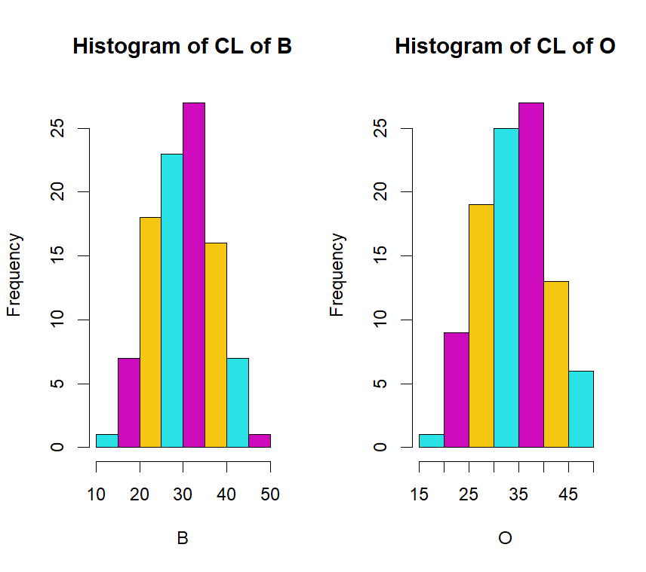

- Both B and O have one high peak and are slightly right skewed. However, B is has a sharper peak than O, and closer to a normal distribution, whereas O is slightly platykurtic, and slightly longer tail than B.

Q5.
plot(crabs[4:8],
col = "darkgreen"
)

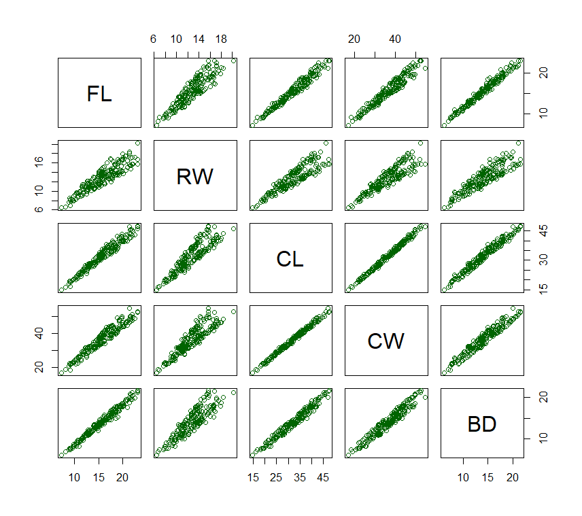
- Across all pairs, you can see very strong correlation between all the variables. However, the ones with the strongest correlations are between CL and CW, which has a sharp linear line.
RW’s correlation with all variables, all though strong, appears weaker and compared with the other variables and is more spread out at the top, almost splitting into two lines. FL’s diagrams, also show correlation between itself and the other variables.

Q6.
We are asked to study the dataset crabs, which is a dataframe containing observations of a particular species of crabs.
From our analysis, we noticed the data being equally balanced across both species and sex, with equal observations across both. Looking at the data according to species and sex, we noted that BD for the specie O was on average higher than for B.
We also compared their relative means across both species and sex, which showed that for species, Orange had higher mean.
We then also looked at the correlation between the morphological variables, which showed strong correlations across all variables, letting us understand that there is a clear relationship between all variables, which is very proportional in nature.

Q4.
a

FLmean_Sex <- aggregate(FL ~ sex,
data = crabs,
FUN = mean
)

RWmean_Sex <- aggregate(RW ~ sex,
data = crabs,
FUN = mean
)

CLmean_Sex <- aggregate(CW ~ sex,
data = crabs,
FUN = mean
)

CWmean_Sex <- aggregate(CW ~ sex,
data = crabs,
FUN = mean
)

BDmean_Sex <- aggregate(BD ~ sex,
data = crabs,
FUN = mean
)

data.frame(
FL_sex = FLmean_Sex,

)
FLmean <- aggregate(FL ~ sp,
data = crabs,
FUN = mean
)

RWmean <- aggregate(RW ~ sp,
data = crabs,
FUN = mean
)

CLmean <- aggregate(CW ~ sp,
data = crabs,
FUN = mean
)

CWmean <- aggregate(CW ~ sp,
data = crabs,
FUN = mean
)

BDmean <- aggregate(BD ~ sp,
data = crabs,
FUN = mean
)

SpecieMeans <- as.table(as.matrix(data.frame(
meanFL = FLmean$FL,
meanRW = RWmean$RW,
meanCL = CLmean$CL,
meanCW = CWmean$CW,
meanBD = BDmean$BD
)))
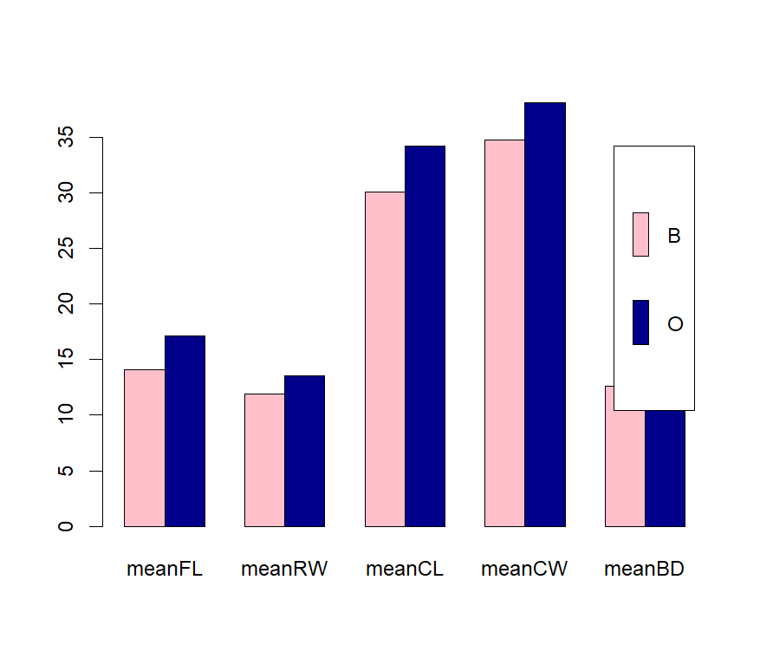
par(mfrow = c(1,2))

barplot(
SpecieMeans,
beside = T,
col = c("pink","darkblue"),
legend.text = c("B", "O")
)

